1. Practice Installing docker,docker-compose and explore all docker commands
2. Create custom docker images of your own and push to docker hub

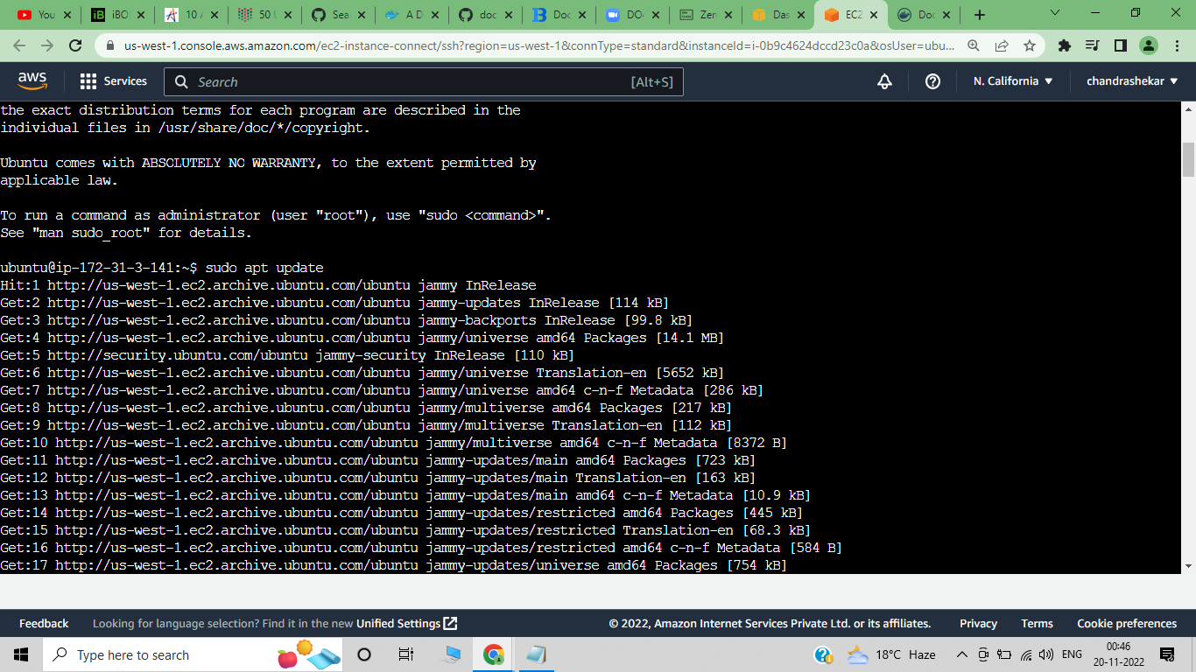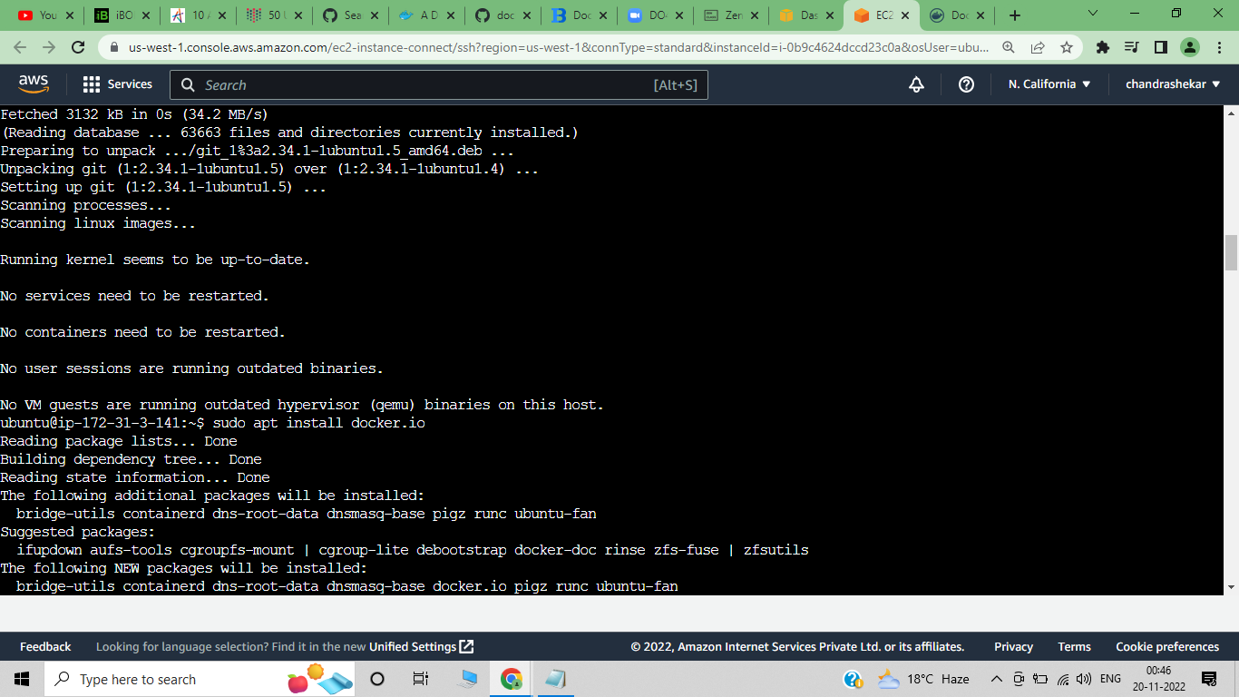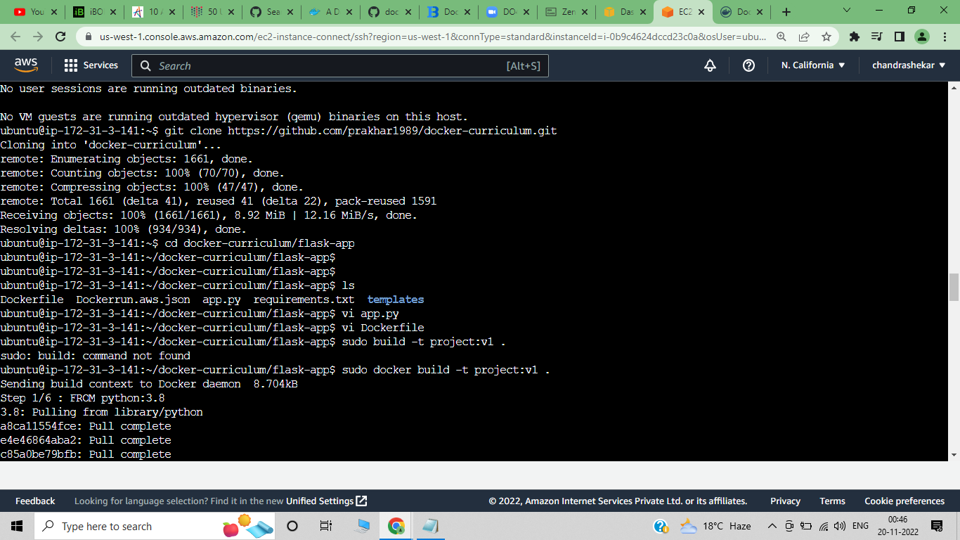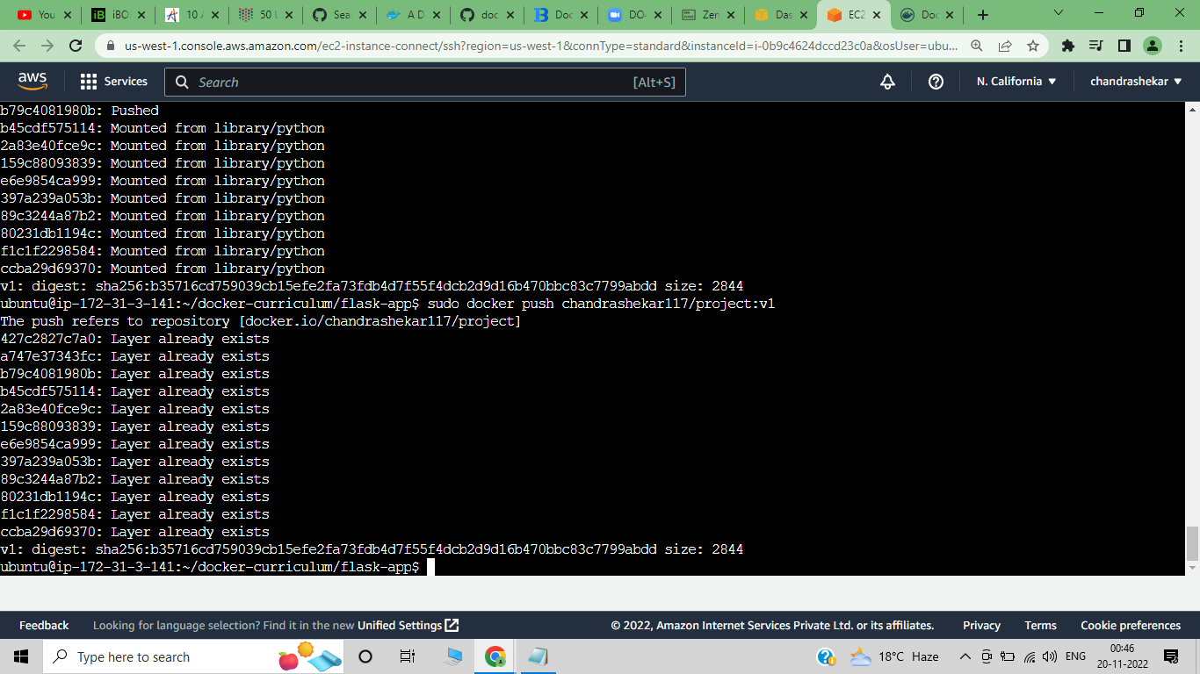

Vi docker-compose.yml

Version: 3.9

Services:

appl:

image: test:v3

container_name:test

restart:always

sudo docker-compose up -d

Docker hub:- chandrashekar117/guvi